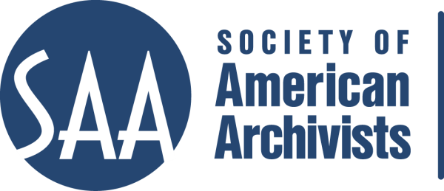
CE Workshop Evaluation Form
Arrangement and Description Track

Workshop Evaluation Form:

Title | Archivist’s Guide to Balancing Legal Issues in Photographic Collections
Directions:
- Quantitative: Each item below begins with a bolded statement. Score each with a 1-5 ranking to indicate your assessment of the veracity of that statement based on your review of workshop overviews/agendas, evaluations, and other materials.
- Qualitative: In the comments section for each item below, please respond to the additional questions posed and any related issues that this workshop raises for you.
- Provide any additional assessments or comments not relevant to one of the specific, numbered areas in the space provided following the table.

Please place an “x” in the appropriate column, use 1=low, undesirable, to 5=high, excellent. |  |  | 1 | 2 | 3 | 4 | 5
1. Does the content appeal to its specified audience? Does it indicate specific categories of archivists and/or levels of expertise to assist potential participants in determining the workshop's relevance for them?  Comments: |  |  |  |  |  |  | X
2. To what extent does the subject matter reflect current archival practices and theory commonly accepted in the profession?  Comments: |  |  |  |  |  |  | X
3.. How relevant/appropriate are the teaching and delivery methodologies (lecture, video, PowerPoint, exercises, film, audiotape, discussion, simulation, case study, opportunities for in-course feedback, etc.) to the articulated goals and objectives, and to the content?"  Comments: I am assuming lecture and discussion, but this area of the description should be added/expanded. |  |  |  |  |  | X
4. How workable is the time line or agenda for the course? Is there sufficient detail to indicate how the workshop will evolve? Does it allow sufficient time for active engagement between course participants and the instructor(s)?  Comments: |  |  |  |  |  |  | X
5. To what degree does the list of assigned readings support the content of the proposal?  Comments: Reviewed the Resources List |  |  |  |  |  |  | X
6. Does the presentation support the Learning Outcomes in the descriptions?  Comments: Suggest expanding the description to include Learning Outcomes and teaching methodology |  |  |  |  | X
 | A&D Track Considerations
 | 1.Does this content bridge, enhance, and/or build on other workshops (If so, please name) | Unknown
 | 2.Does this build on other workshops not on the list? | Unknown
 | 3 Should this be part of the A&D Track? | YES
 | 4.Where would this workshop fall in the sequence of an A&D track? | Unknown
 | Why?
 | 5. What tier does this workshop fall in? (See attached tiers) | See attached list of tiers and definitions Tiers not attached
 | 6. Target Audience | Attached list of tracks can be used to indicate appropriate level of experience and job function
 | 7. Is the suggested prior “experience/knowledge” appropriate? | N/A
 | 8. Learning Outcomes:  Are they appropriate and/or relevant? | Recommend this area should be expanded.
9. What should they be?
Please list learning outcomes.
 | 10. Can you make suggestions for competencies this workshop would fulfill? | No
 | 11. Would parts of the content lend themselves to a different format? | Check one: Webinar: - 30 minute - 90minute In person: - 1/2 day - 1 day - 2 day
 | 12. Which parts?
 | 13. Does it lend itself to repurposing as an audio CD? | No
 | Which parts?

Comments: This course appears to be current and relevant to the field. As noted, the workshop description should be expanded to include teaching methodology and learning outcomes sections.

